Manage Concentration Risk
Using a Data Warehouse, Power BI and Excel

This article will describe an integrated approach to meet a regulatory requirement of the NCUA’s Supervisory Letter -Concentration Risk. By adopting a professional data warehouse (such as VeriCU available through The Knowlton-Group), and Microsoft’s BI tools, Power BI and Excel, the Net Worth Concentration report as shown below, can be generated contributing to the management of Concentration Risks.
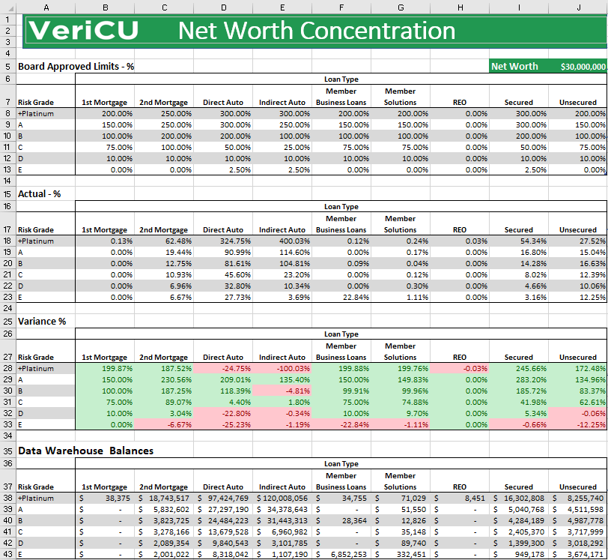
In March 2010, the NCUA released the Supervisory Letter – Concentration Risk in response to the Great Recession of 2008 – 2009. This Supervisory Letter provided instructions to Credit Unions relating to the management of Concentration Risk. The Letter instructed Credit Unions to “identify, measure, monitor and control concentration risk”. The NCUA instructed Credit Unions to “Maintain Comprehensive and Accurate Data” and informed them that “Management reporting must be periodic and timely…”.
The Data Warehouse Role
The data warehouse is the repository of historical data a Credit Union needs. The data in the data warehouse is retrieved regularly and directly from the Credit Union’s core data processing system. The data warehouse has the requisite historical data to manage Concentration Risk, such as loan balances, loan type and credit score. The data warehouse is considered “the single source of truth”. The data warehouse meets the regulatory requirement to “Maintain Comprehensive and Accurate Data”.
Below is a typical set of tables and columns that contain data residing in a data warehouse. This is the “Comprehensive and Accurate” data and is importantly available on demand.
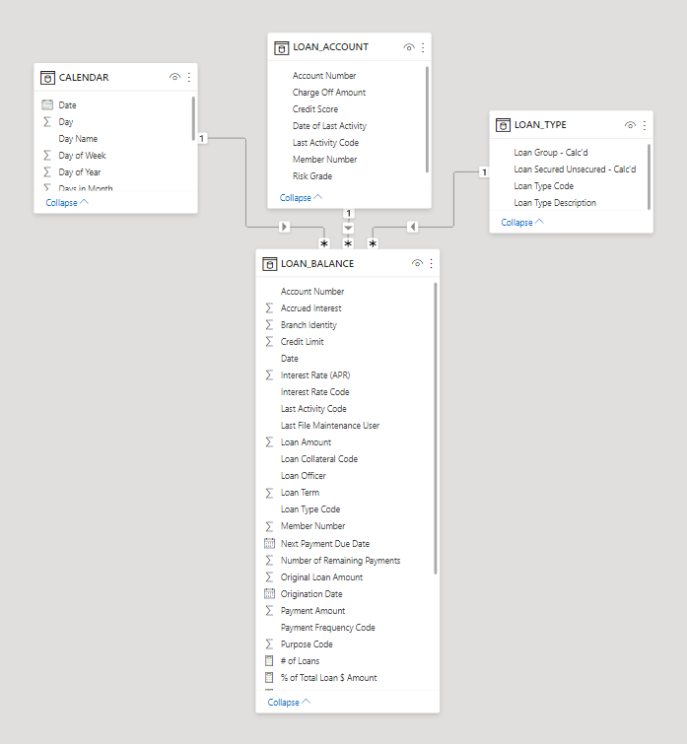
In the final Excel worksheet that will be built, the below range of cells are retrieved directly from the data warehouse. (Note this range is immediately below the desired report starting at cell A40). Getting this essential data into Excel will be described next.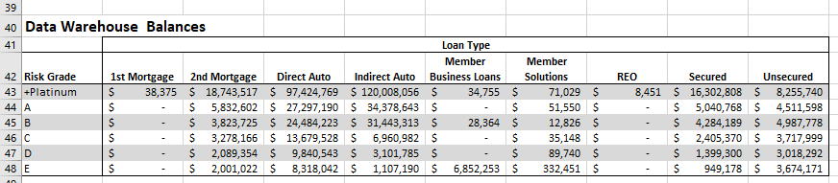
Power BI’s Role
Power BI is Microsoft’s Business Intelligent tool. Power BI queries and loads the data from the data warehouse. A user can build formulas and visuals in Power BI using this data. This loaded data (from the data warehouse) plus the additional formulas become data elements of the Power BI dataset.
Below is a Power BI report that has some of the data grids as the desired report. However, it lacks the Board Approved Limits section and the subsequent variance section. This is because the data warehouse does not store static one-time data like the Board Approved Limits.
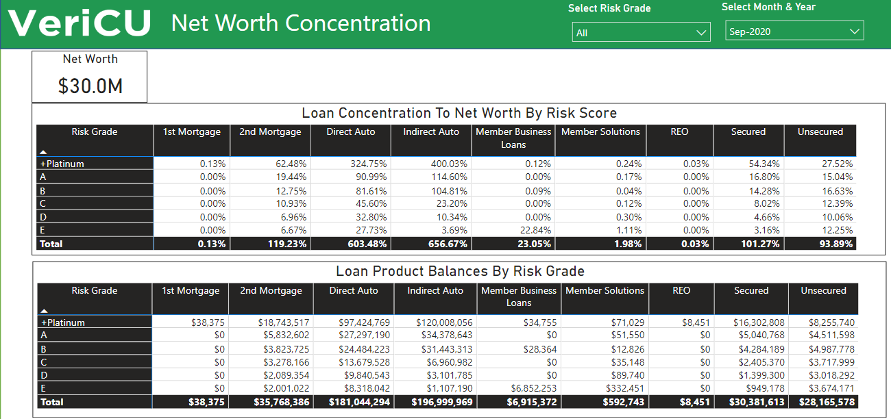
So, how is Power BI contributing to the desired report? The Power BI dataset of all the date warehouse fields and the additional formulas can be referenced in Excel.
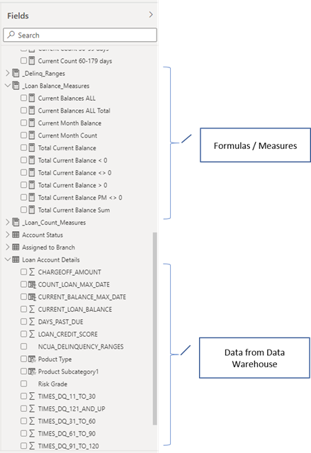
Excel’s Role
Excel retrieves data from the Power BI dataset to build the desired report. This is accomplished by choosing:
- The Data Tab
- The Get & Transform Group (hidden behind the drop-down menu)
- The Get Data command
- The From Power BI menu item
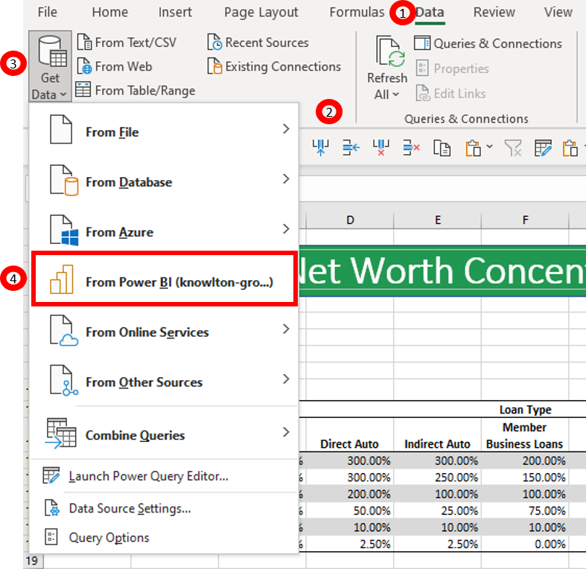
Excel opens a window for a list of available datasets.
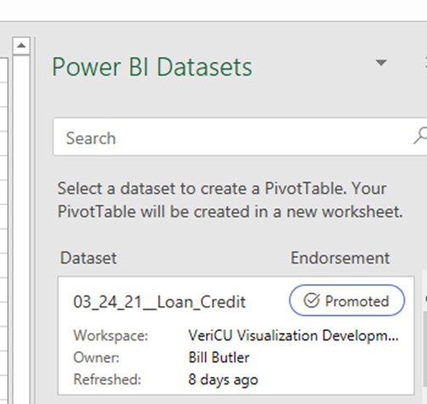
Upon choosing a Power BI dataset, Excel launches a Pivot Table with the PivotTable Fields. Note in the PivotTable that the dataset name is viewable – “ 03_24__Loan_Credit”.
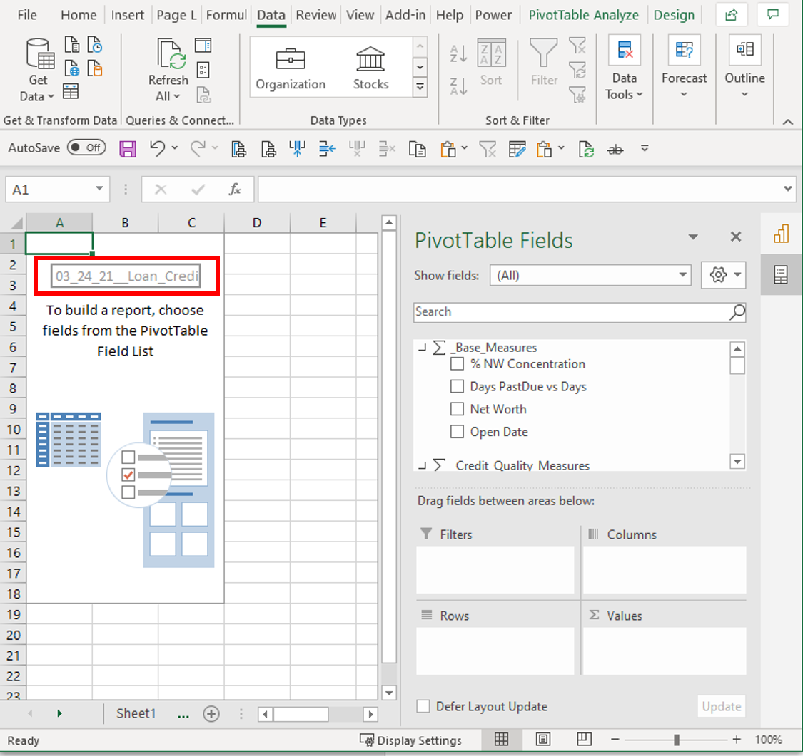

The next step is to build a PivotTable with the necessary data. Place the PivotTable Fields in the following sections:
- On Filters place Account Status - Account Status Code and Process Date- MonthYear,
- On Columns place Product - PRODUCT_CATEGORY
- On Rows place Loan Account Details - Risk Grade
- On Values place Loan Balance Measures - Total Current Balance <> 0
- In the Filter section set ACCOUNT_STATUS_CODE to “Open” and MonthYear to “Sep-2020”
Below is the resulting PivotTable
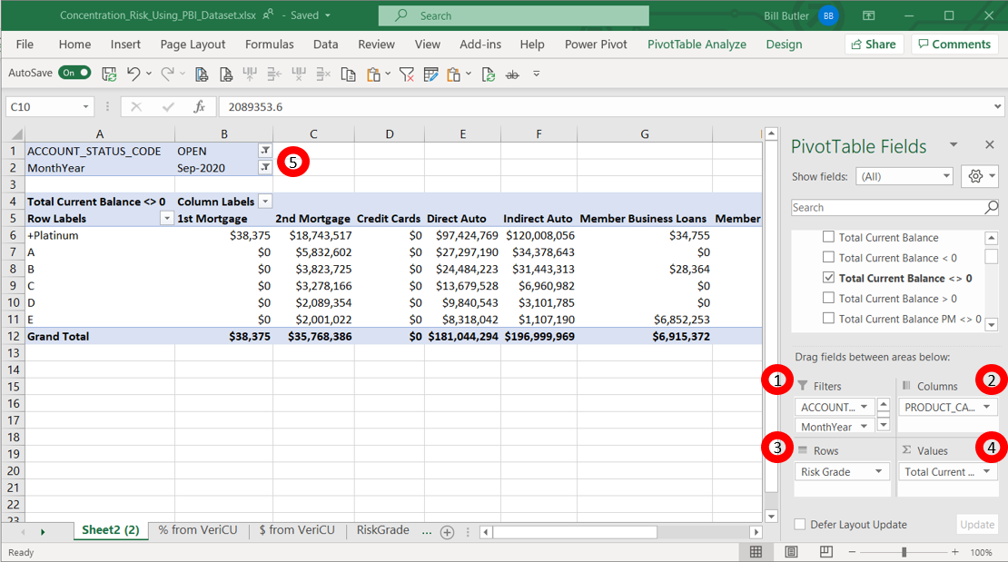

But PivotTables have reporting limits, so we convert the PivotTable into Excel CUBE FORMULAS. I will not explain in depth how these CUBE FORMULAS work, but will show the short cut available in Excel to use CUBE FORMULAS (see https://www.excelcampus.com/cubevalue-formulas/ for a good reference).

Here are the shortcut steps. Make sure the PivotTable is active. In the Ribbon chose:
- The PivotTable Analysis Tab
- The Calculations Group (hidden behind the drop-down menu)
- The OLAP Tools command
- The Convert to Formulas menu item
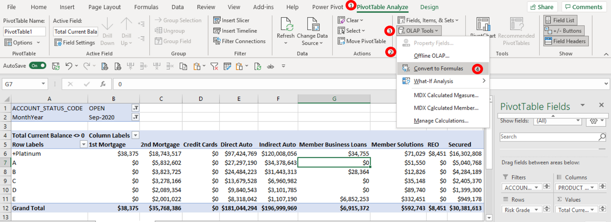
Note the dialog box and choose “Convert”.
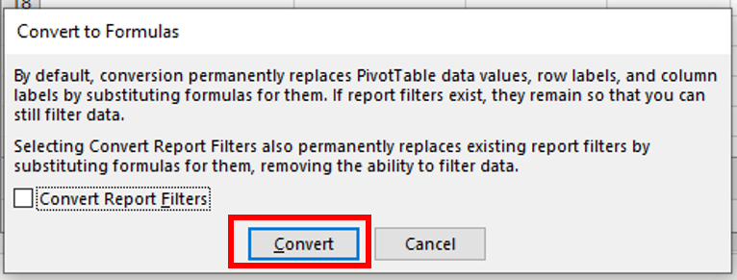

The Pivot Table has been converted into CUBE FORMULAS. Note the formula for B6 is =CUBEVALUE("03_24_21__Loan_Credit Quality2",$B$1,$B$2,$A$4,$A6,B$5). The formulas in this range can be treated just like any regular cells in Excel.
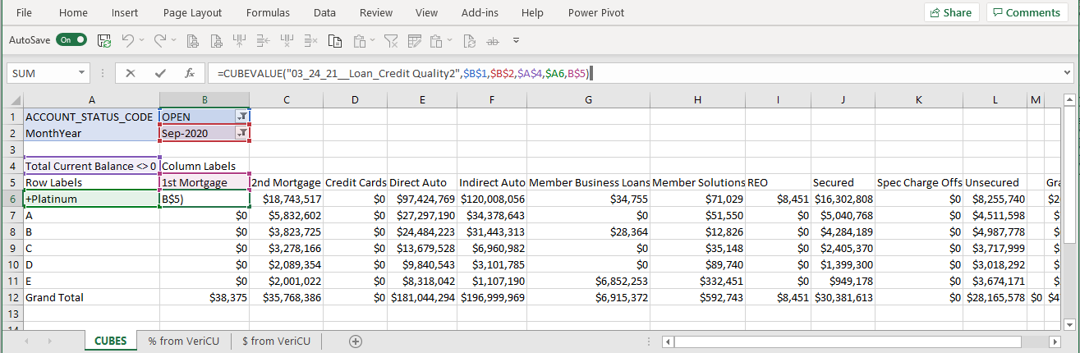
This range of cells can be configured and positioned in the desired report. This is the data warehouse data needed to calculate the Net Worth Concentration percentages (as was shown previously).

All the data elements of the are now in place to generate the Risk Concentration Report. Here are the key ranges used by the Excel worksheet that generates the report.
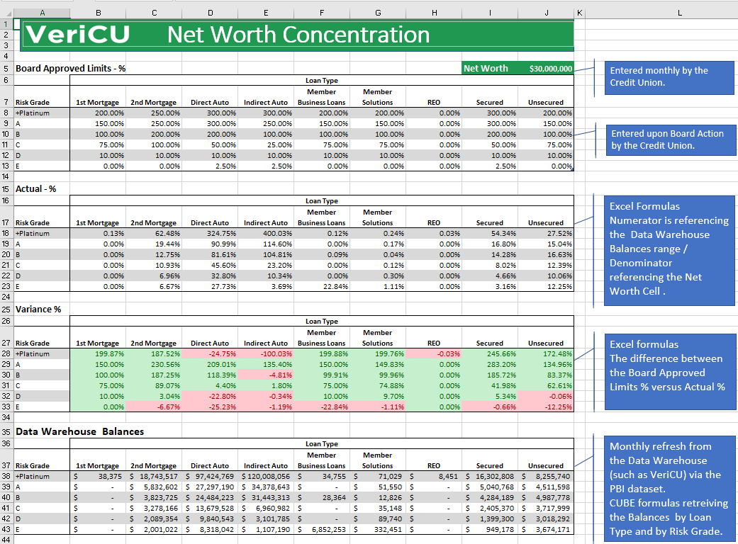

According to the NCUA’s Supervisory Letter - Concentration Risk, Credit Unions are required to “identify, measure, monitor and control concentration risk” and “Maintain Comprehensive and Accurate Data” and “Management reporting must be periodic and timely…”.
By using this integrated approach of adopting a Data Warehouse, enhanced by a Power BI dataset, building Excel CUBE formulas that access the Power BI dataset, a Credit Union can build an important report for the Board and Management to manage the Credit Unions Loan Concentration Risk. Plus, it is very likely this integrated method can be used to solve other reporting needs the Credit Union may have.

Notes
(1) https://www.ncua.gov/regulation-supervision/letters-credit-unions-other-guidance/concentration-risk

